The Care Information Exchange

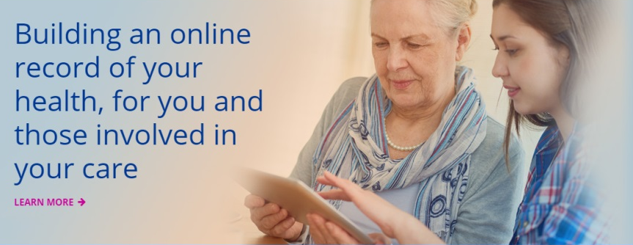

The goal of the Care Information Exchange is to make sure you receive the best care and to help you feel more in control of managing your health. It will provide online access to health records for you and the health and care professionals involved in your care.

What it means for you
The Care Information Exchange can help you:
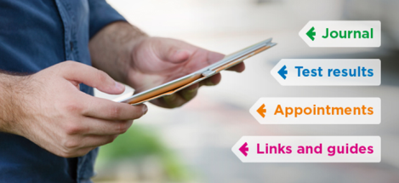
- Manage your healthcare from the comfort of your own home.
- Reduce the time you need to spend attending routine medical appointments
- Give all the professionals involved in your care a better, more rounded view of your medical history, and improve your health as a result.

Getting started
If your professionals are using the Care Information Exchange, they may invite you to get access. You will need to provide an email address and photographic ID such as a passport or driving licence. Your email address will be your unique user name. We will use it to send you your initial instructions for activating your account as well as notifications when there are updates to your information. Once you have completed the registration, you will be able to log in from the Care Information Exchange website from any computer or smartphone with internet access.

Keeping your information secure
The Care Information Exchange is hosted within the NHS secure network. Your information is encrypted so that only you and those people with consent to view the information can do so. All health and care professionals have a duty to protect the confidentiality of patient and service user information.

Opting out
We put information that we hold about you on the Care Information Exchange. This gives the opportunity for other professionals involved in your care to see it and can help ensure you get the best care and avoid unnecessary tests and treatment. If you do not want your information to be shared, you can opt out by informing your healthcare professional or by using the contacts form on the Care Information Exchange website.

How the Care Information Exchange works
Once you have access log on at www.careinformationexchange-nwl.nhs.uk. Here are some of the features you can use:

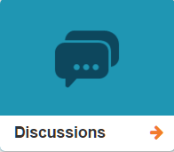 | - A list of your A&E attendances or stays on our wards from April 2016 onwards.  - Your healthcare professionals may invite you to send and receive messages from here.
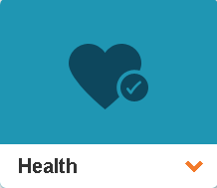 | - Blood tests and x-rays that we did for you from May 2016 onwards will be visible under the laboratory and imaging tabs.  - You can also add a range of information about your health including diagnoses, allergies, symptoms, and measurements such as pulse and blood pressure.
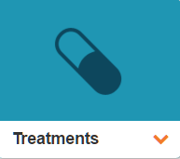 | - Your health professional may provide a care plan with a record of your treatment including your medications.  - Your health and care professionals may add links in your library to help and advice materials. And you can add your own.  - Record the medications that you are taking.
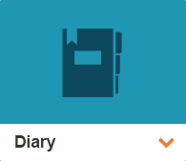 | - Outpatient clinic appointments which were booked from April 2016 onwards will show in your diary automatically. You can also add other appointments yourself.  - There is a journal for you to write down your thoughts and observations about your health.
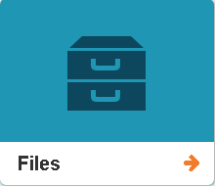 | - This is the place to add documents and images. For example, you can scan letters and store them here.
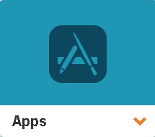 | - If you are using a personal healthcare or fitness tracker, you may be able to upload data from it direct into your record.
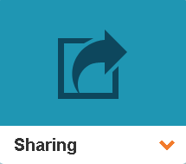 | - This is where you control who can see your record. You can invite health and care professionals, carers, friends and family. And you can choose what type of information they can see: general, social, mental or sexual.

The Care Information Exchange has been funded by Imperial College Healthcare Charity.
Patients Know Best is the computer system at the heart of the Care Information Exchange
For more information go to www.careinformationexchange-nwl.nhs.uk

